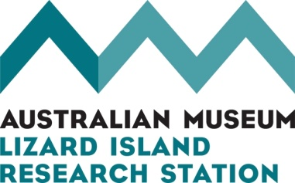
Application for Undergraduate Internship

Personal details
Name

Date of birth

Email

Phone

University

Course

Month/Year first enrolled in this course

Current Grade Point Average (or similar metric)
Indicate dates between which you would be available to take up an internship of four weeks duration (you can list two periods)
Date of application

In 200 words or less, tell us why you want to become a LIRS intern.
Diving and boating
Do you have a scuba diving certificate? If so, show issuer and level.
Do you keep a scuba diving log? If so, how many hours/minutes have you logged?
And how many of those hours/minutes were during your initial training course?
Do you have a current AS2299 dive medical? If so, show its date.
Do you have a current certificate in first aid?
If so, show its date.
Do you have a current certificate in providing medical oxygen? If so, show date.
Do you have a current Australian recreational boat licence?

Referees
Please provide information for three people who may be contacted for a reference.
Name | Phone | Email | Relationship to applicant

How to submit
Send a single email with the three documents listed below as attachments to lizard@austmus.gov.au with the subject line Undergraduate Internship application <your name>
- Completed application form
- Proof of your current status in a relevant university course
- Academic transcript showing grades achieved to date in that course
Do not send a cover letter or any other documents. They will not be read.
More information
Dr Lyle Vail and Dr Anne Hoggett, Directors
Lizard Island Research Station
www.australianmuseum.net.au/Lizard-Island-Research-Station/
lizard@austmus.gov.au
Phone: 07 4060 3977

